***Azure CLI***

Azure CLI (Command-Line Interface) is a powerful, cross-platform command-line tool that enables users to manage Azure resources and automate cloud tasks. It’s widely used by developers, administrators, and DevOps engineers for efficient Azure management. Here’s a breakdown of its features, capabilities, and applications:

**Key Features of Azure CLI**

1. **Cross-Platform Support**:
   * Azure CLI works on Windows, macOS, and Linux, allowing a consistent experience across different operating systems.
   * You can also run it directly in the Azure Cloud Shell without any setup.
2. **Resource Management**:
   * Azure CLI provides commands to manage Azure resources like Virtual Machines (VMs), storage accounts, resource groups, networks, databases, and more.
   * Users can create, modify, and delete resources in Azure directly from the command line.
3. **Script Automation**:
   * CLI scripts can automate repetitive tasks, such as deployment, configuration, and scaling of resources.
   * These scripts can be integrated into CI/CD pipelines, making Azure CLI a great tool for DevOps processes.
4. **Integration with Azure Services**:
   * Supports comprehensive interactions with Azure services, such as Azure Kubernetes Service (AKS), Azure Virtual Network, Azure Storage, and Azure Functions.
   * Provides commands for managing complex services like Azure Virtual Machine Scale Sets (VMSS), Load Balancers, and Application Gateways.
5. **Authentication Options**:
   * Azure CLI supports various authentication methods, including user accounts, managed identities, and service principals.
   * It also supports Azure Active Directory (AAD) for secure, role-based access control (RBAC).

***Create VM using Azure CLI***

***Start with creating a Resource Group***

az group create --name learn-azure-cli --location eastus

***Create VM with Vnet***

az vm create --resource-group learn-azure-cli --name vmName --image Ubuntu2204 --vnet-name default --subnet default --generate-ssh-keys

***Logging In and Setting Up***

* **Login** to your Azure account:

bash

az login

* **Set the default subscription** (if you have multiple):

bash

az account set --subscription "<Your_Subscription_ID>"

**3. Common Azure CLI Commands**

* **Resource Group**:
  + Create:

bash

az group create --name <ResourceGroupName> --location <Location>

* + List:

bash

az group list

* + Delete:

bash

az group delete --name <ResourceGroupName>

* **Virtual Machines (VMs)**:
  + Create a VM:

bash

az vm create --resource-group <ResourceGroupName> --name <VMName> --image <ImageName> --admin-username <Username> --generate-ssh-keys

* + Start, Stop, and Restart:

bash

az vm start --name <VMName> --resource-group <ResourceGroupName>

az vm stop --name <VMName> --resource-group <ResourceGroupName>

az vm restart --name <VMName> --resource-group <ResourceGroupName>

* **Virtual Network (VNet)**:
  + Create a VNet:

bash

az network vnet create --name <VNetName> --resource-group <ResourceGroupName> --subnet-name <SubnetName>

* + List VNets:

bash

az network vnet list --resource-group <ResourceGroupName>

* **Storage Accounts**:
  + Create:

bash

az storage account create --name <StorageAccountName> --resource-group <ResourceGroupName> --location <Location> --sku Standard_LRS

* + List storage accounts:

bash

az storage account list --resource-group <ResourceGroupName>

**4. Using CLI with JSON Output**

By default, Azure CLI returns JSON-formatted responses. To specify output formats (like table or json), use:

bash

az vm list --output table

**5. Help and Documentation**

For any Azure CLI command, you can append --help to see usage details:

bash

az vm create --help

***Scenario 1: Set Up a Resource Group and Deploy a Virtual Machine***

**Objective**

Create a resource group and a virtual machine in Azure. Set up a VNet and a subnet, and deploy a VM with an SSH key.

**Steps**

1. **Create a Resource Group**
   * **Azure CLI**:

bash

az group create --name azurecli --location AustraliaEast

1. **Create a Virtual Network (VNet) and Subnet**
   * **Azure CLI**:

bash

az network vnet create --name azureVent --resource-group azurecli --location AustraliaEast --address-prefix 11.0.0.0/20 --subnet-name azuresubnet --subnet-prefix 11.0.9.0/24

1. **Deploy a Virtual Machine**
   * **Azure CLI**:

bash

az vm create --resource-group azurecli --name azureVm --image Ubuntu2204 --vnet-name azureVnet --subnet azureSubnet --admin-username sysadmin --generate-ssh-keys

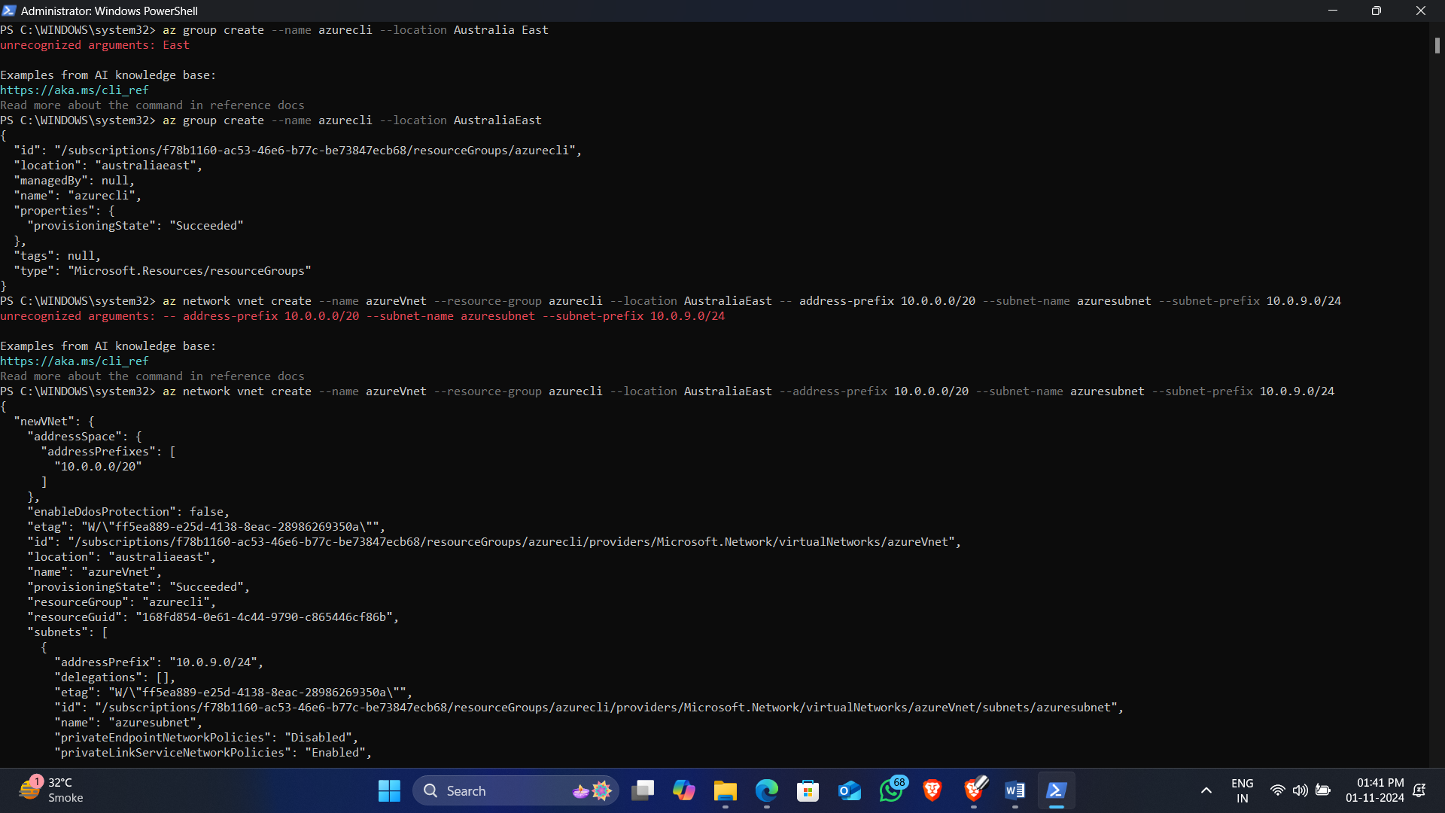

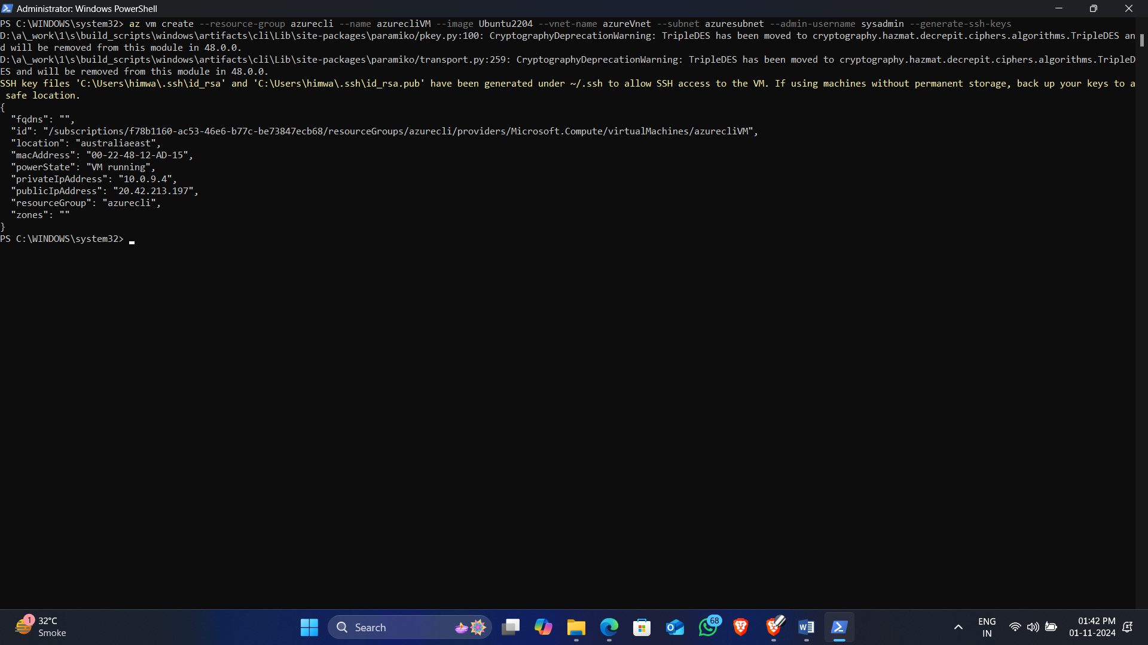

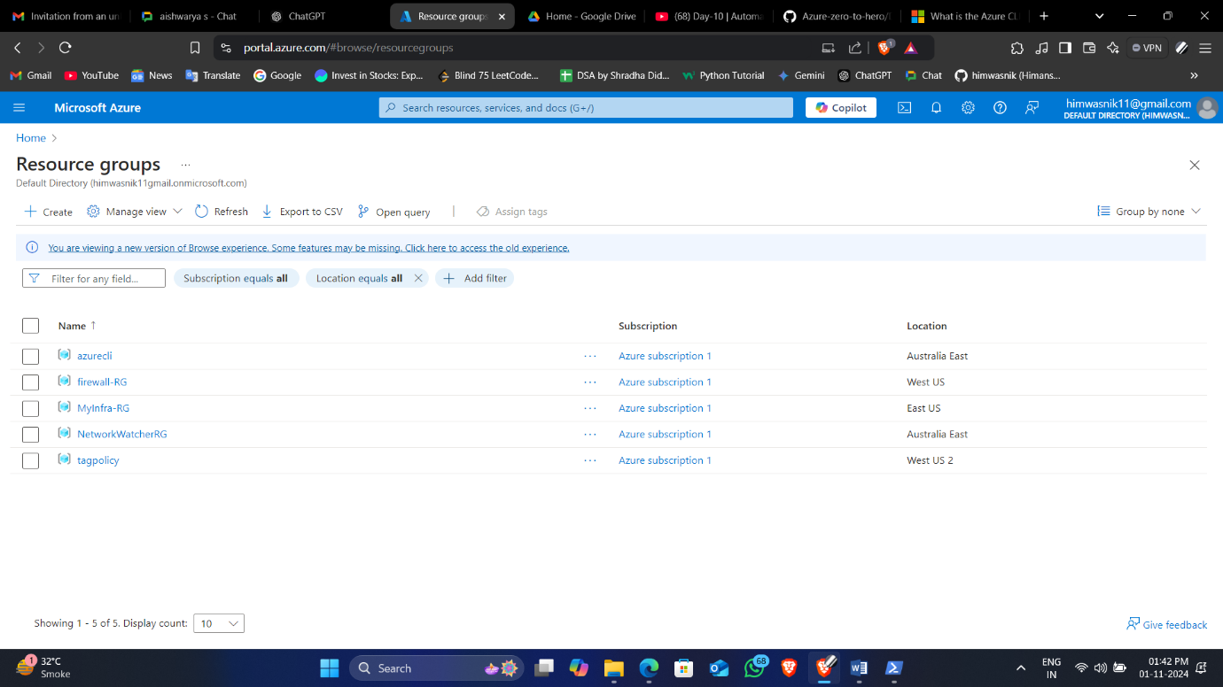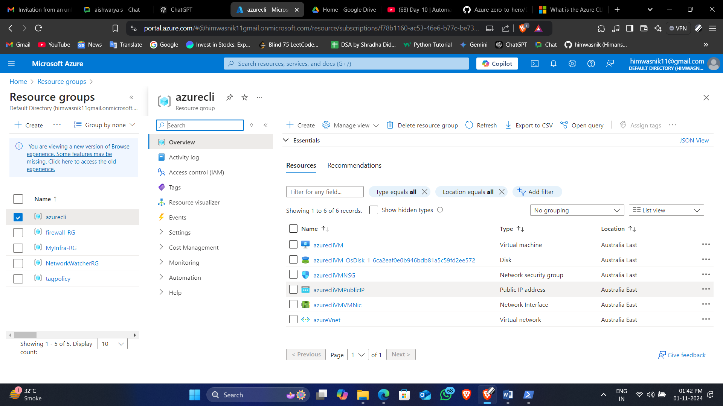

***Scenario 2: Automate Scaling of Virtual Machines in a Virtual Machine Scale Set (VMSS)***

**Objective**

Create a VM Scale Set, configure autoscaling, and verify the scaling settings.

**Steps**

1. **Create a Virtual Machine Scale Set**
   * **Azure CLI**:

bash

az vmss create --resource-group azurecli --name azurevmss --image Ubuntu2204 --upgrade-policy-mode automatic --admin-username sysadmin --generate-ssh-keys

1. **Configure Autoscaling**
   * **Azure CLI**:

bash

az monitor autoscale create --resource-group azurecli -resource azurevmss --resource-type Microsoft.Compute/virtualMachineScaleSets --name autoscaleVMSS --min-count 1 --max-count 3 --count 1

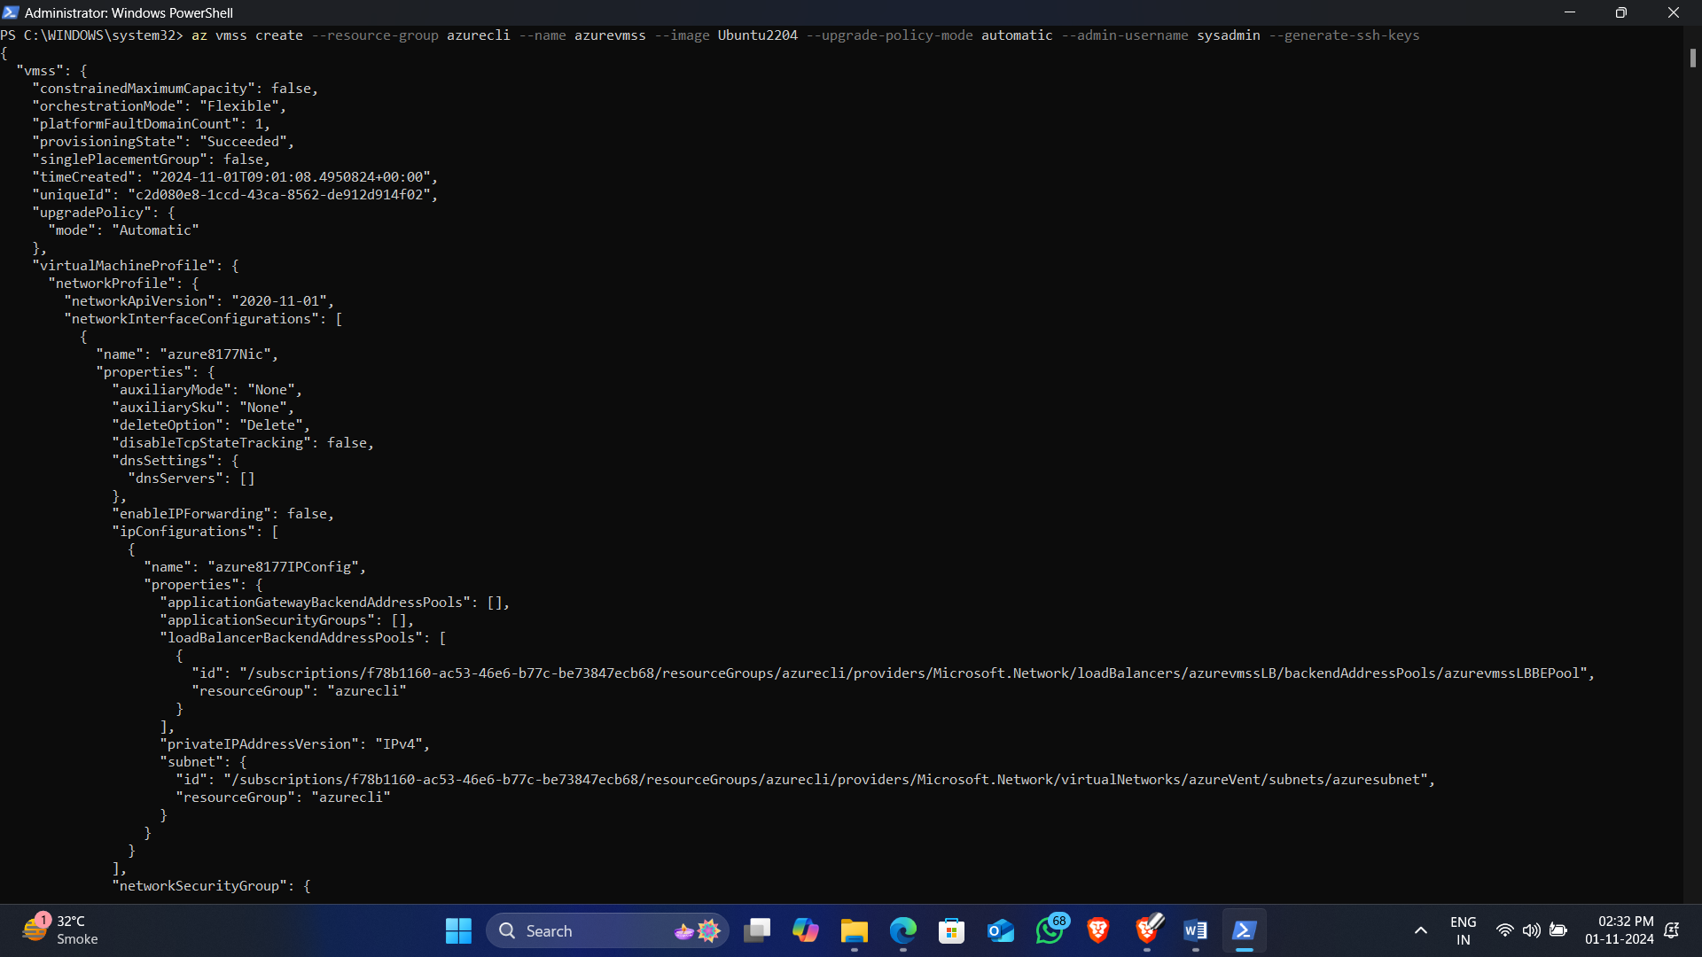

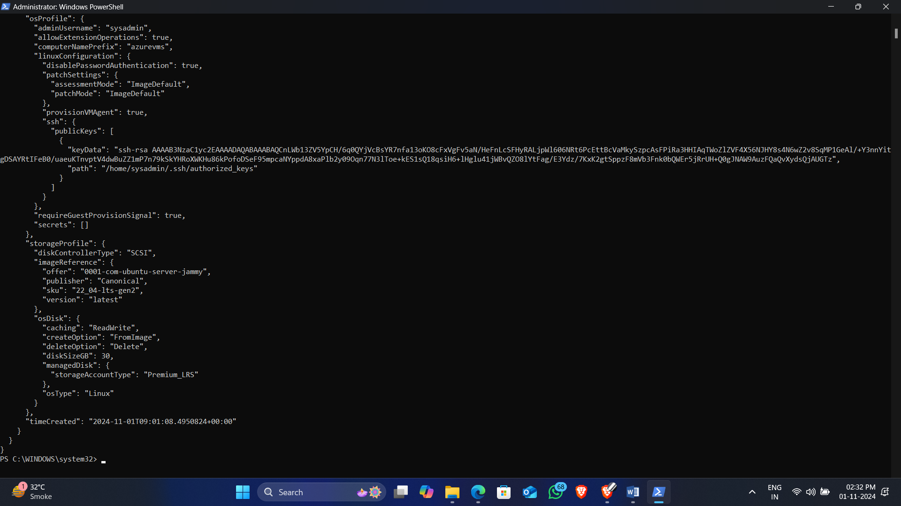

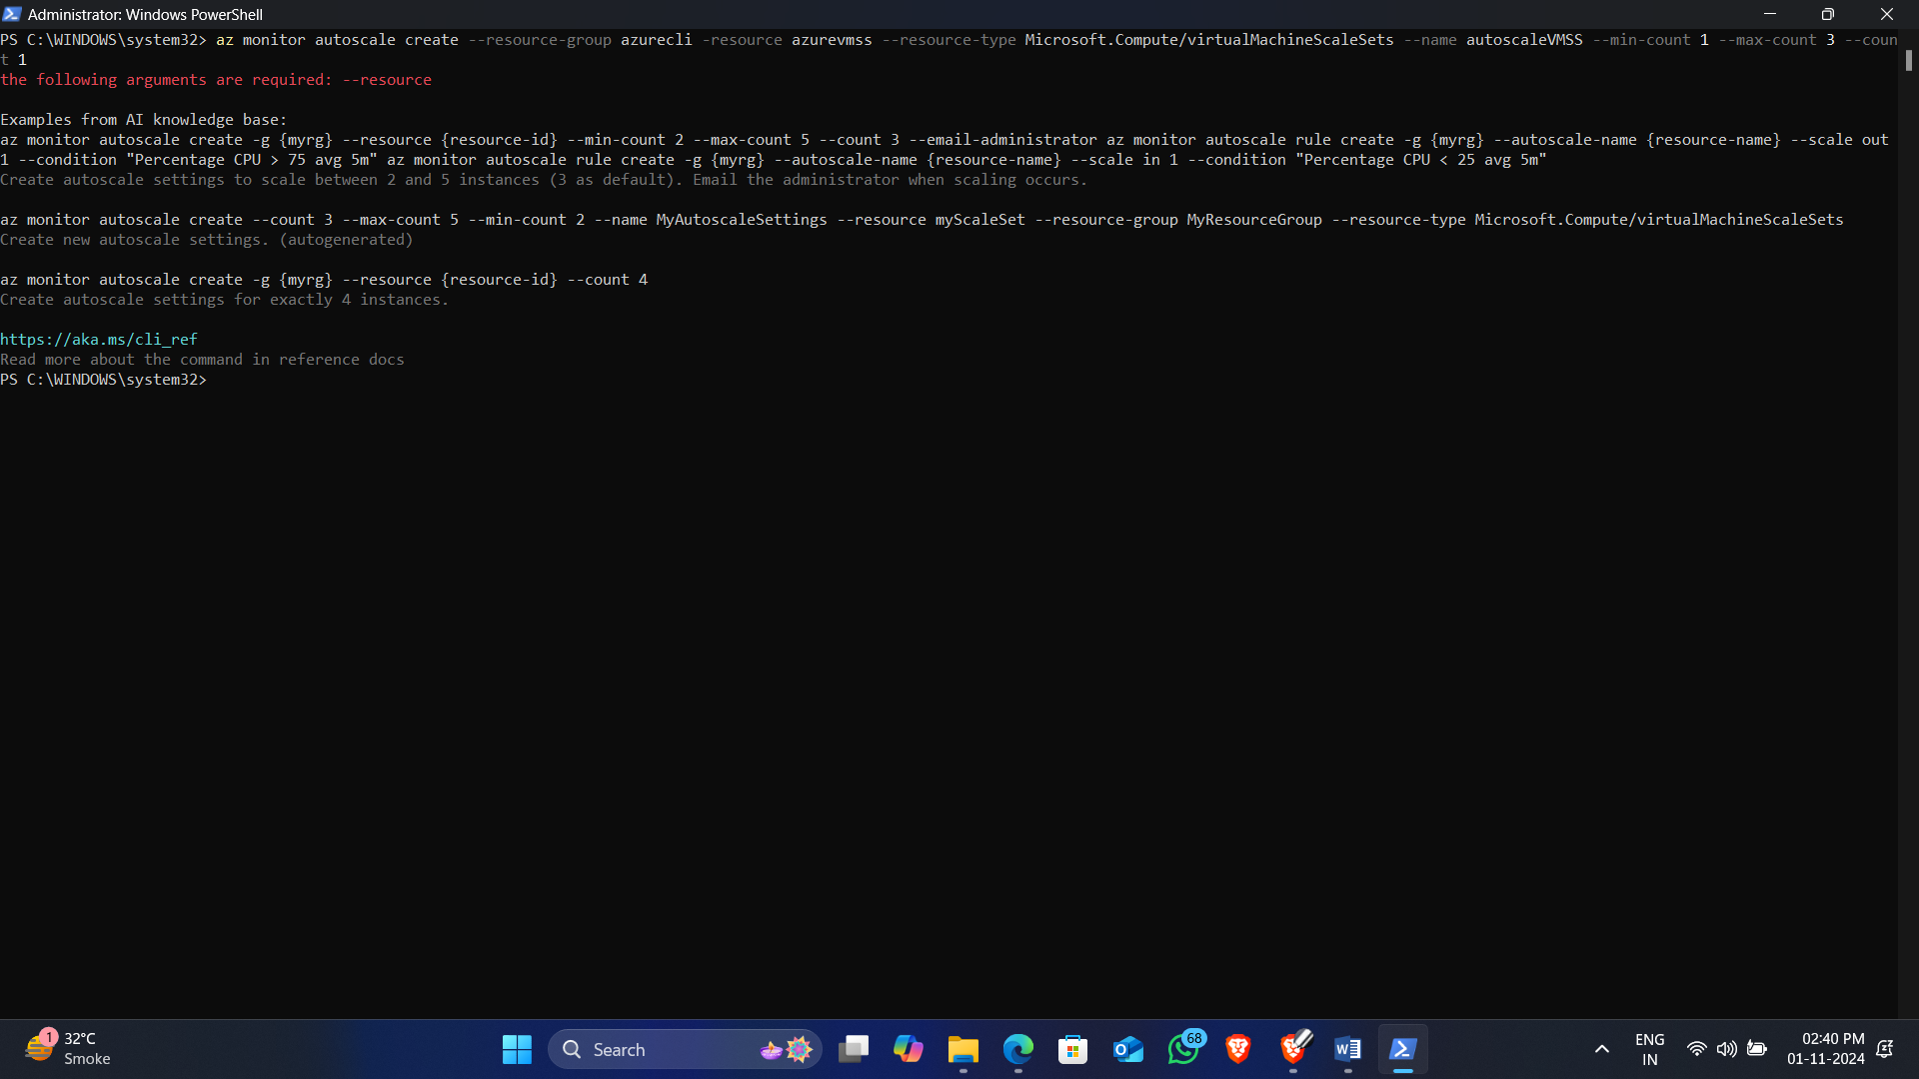

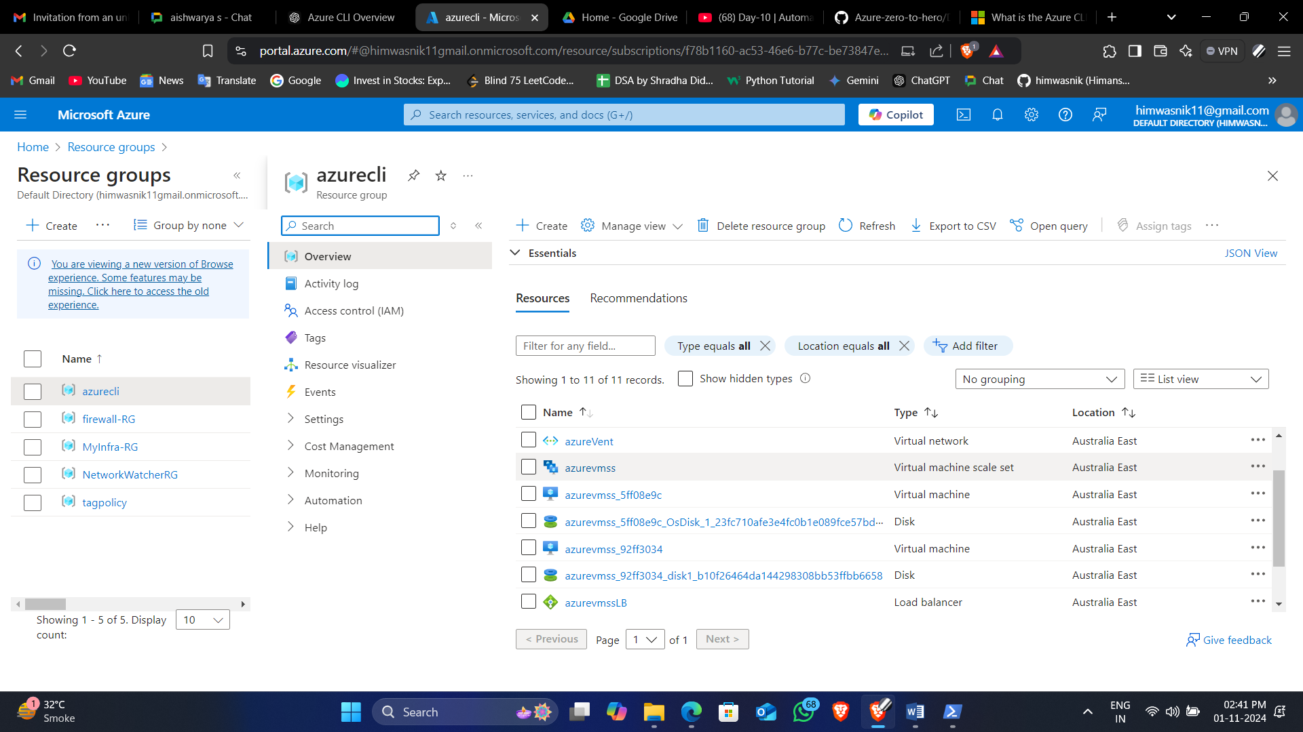

***Scenario 3: Configure Storage and Manage Files with Azure CLI and PowerShell***

**Objective**

Create a storage account, configure a blob container, and upload/download files using CLI and PowerShell.

**Steps**

1. **Create a Storage Account**
   * **Azure CLI**:

bash

az storage account create --name myhim1 --resource-group MyInfra-RG--location aus --sku Standard_LRS

1. **Create a Blob Container**
   * **Azure CLI**:

bash

az storage container create --name mycontainer --account-name myhim1

***Installing Azure CLI on Linux***

1. **Update the Package List**: First, update the package list to ensure you have the latest package information:

bash

sudo apt-get update

1. **Install Required Packages**: Ensure that you have the required packages for the Azure CLI installation:

Bash

sudo apt-get install apt-transport-https ca-certificates curl software-properties-common

1. **Import the Microsoft GPG Key**: Import the Microsoft GPG key for the Azure CLI:

bash

curl -sL https://packages.microsoft.com/keys/microsoft.asc | sudo apt-key add -

1. **Add the Azure CLI Software Repository**: Add the Azure CLI software repository to your system:

bash

echo "deb [arch=amd64] https://packages.microsoft.com/repos/azure-cli/ $(lsb_release -cs) main" | sudo tee /etc/apt/sources.list.d/azure-cli.list

1. **Update the Package List Again**: After adding the repository, update the package list again:

bash

sudo apt-get update

1. **Install the Azure CLI**: Now install the Azure CLI:

bash

sudo apt-get install azure-cli

**Verifying the Installation**

Once the installation is complete, verify that Azure CLI is installed correctly:

bash

az --version

***Uploading Files to Blob Storage***

After successfully installing the Azure CLI, you can then run the command to upload your files:

1. **Navigate to the Directory** (if not already there):

bash

cd /new_chatapp/fundoo/fundoo

1. **Run the Upload Command**:

bash

az storage blob upload-batch --account-name myhim1 --destination mycontainer --source .

This command will upload all files from the current directory (fundoo) to the specified container in your Azure Blob Storage.

**Summary**

* Install Azure CLI using the commands provided above.
* Once installed, you can use the az command to upload your files.

